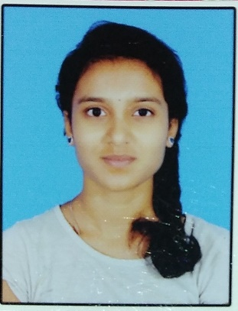**Greeshma CK**

Email – [Greeshmack2003@gmail.com](mailto:Greeshmack2003@gmail.com)

Phone No. - +91 9019035843

Linkedin - [linkedin.com/in/greeshma-ck-53638324b](https://www.linkedin.com/in/greeshma-ck-53638324b)

**__________________________________________________________________________**

* **Career objective:**

Passionate electronics and engineering student looking for hands-on experience. Expertise in a particular domain, seeking opportunities to contribute my theoretical knowledge in innovative projects and develop my skills.

* **Education:**

|  |  |  |  |
| --- | --- | --- | --- |
| **Qualification** | **Institute** | **Year of**  **study** | **Percentage** |
| B.Tech  Electronics and  communication | Gandhi Institute of Technology and  management | 2021-2025 | 7.8(CGPA) |
| Pre-university | Global PU college | 2020 | 76.5% |
| SSLC | Global Residential  school | 2018 | 71.20% |

* **Projects:**
* **Electronic hardware Wumpus world Robot** –

This was a project related to IOT I played a role related to Arduino connection and coding. we a team designed a hardware robot using IOT tools, and sensors the robot was designed in a way where it avoids obstacles reaches the destination and returns to its original place where it started.

**Board** – Arduino | **Language** – C programming

* **Binary to grey & grey to binary**-

Implemented binary-to-Gray and Gray-to-binary code conversion algorithms on an FPGA using Verilog, ensuring efficient and accurate data encoding.

**Board** – FPGA | **Language** – Verilog

* **Keypad Scanner**  -

We implemented a 3x4 keypad scanner using Verilog on an FPGA kit, integrating debouncing techniques for reliable key detection.

**Board** –FPGA kit| **Language** – Verilog

* **Certifications:**
* CMOS digital IC design workshop
* Fundamentals of c programming
* IBM project management fundamentals
* Introduction to cybersecurity
* Python Programming
* 8-bit microcontrollers
* **Extra curriculum:**

IEEE student member | NSS volunteer

* **Technical skills:**
* Basic Level – C programming, Python, Data structures in Python
* Intermediate Level – Verilog code
* Tools - Xilinx vivado, MATLAB, Logism, Multisim, Cadence Virtuoso
* Good at understanding circuit design and analysis
* **Soft skills:**
* problem-solving skills
* Strong communication skills